**51. Loop Dict Types**

--- **note** - Range can be used to look through a dictionary of values as well. So, you can define a dictionary up top and then use range to look through it.

--- tree

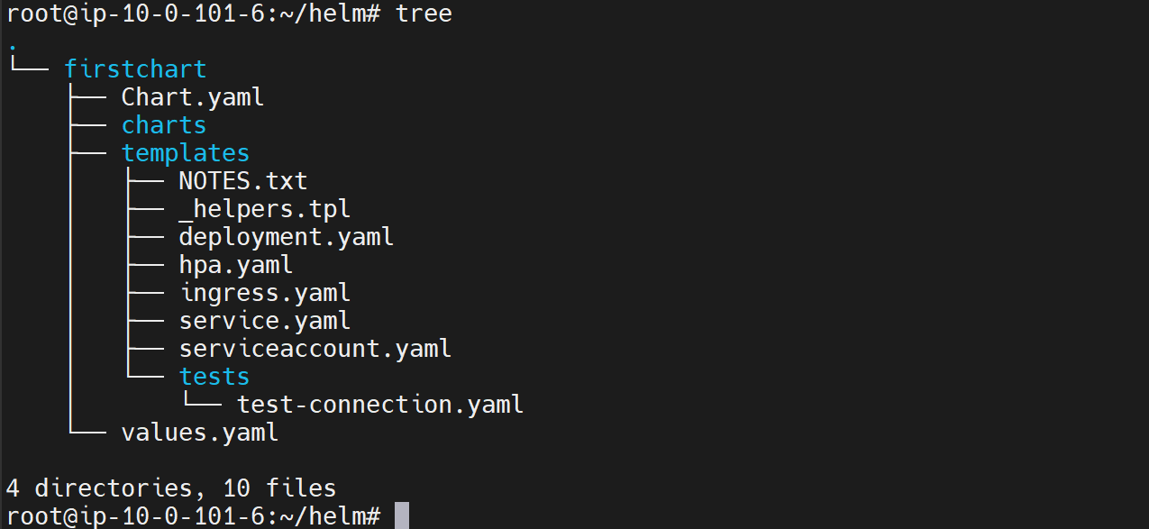

--- cat values.yml

# Default values for firstchart.

# This is a YAML-formatted file.

# Declare variables to be passed into your templates.

my:

  flag: true

  values:

    - usq

    - india

    - mexico

    - brazil

    - uk

replicaCount: 1

image:

  repository: nginx

  pullPolicy: IfNotPresent

  # Overrides the image tag whose default is the chart appVersion.

  tag: ""

imagePullSecrets: []

nameOverride: ""

fullnameOverride: ""

--- **note** - image it has a set of key value pairs. These can be looked at as a dictionary of values.

--- cat deployment.yml

apiVersion: apps/v1

kind: Deployment

  {{- range $key,$value  := .Values.image}}

    - {{$key}}: {{$value | quote | }}

  {{- end}}

spec:

  {{- if not .Values.autoscaling.enabled }}

  replicas: {{ .Values.replicaCount }}

  {{- end }}

  selector:

    matchLabels:

      {{- include "firstchart.selectorLabels" . | nindent 6 }}

  template:

    metadata:

      {{- with .Values.podAnnotations }}

---